FLEXA Digital Pirani Vacuum Sensor FG-04
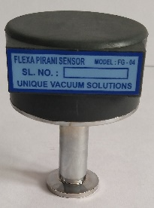
The UVS Model FLEXA series Vacuum Pirani Gauge Controller displays vacuum pressure as measured from a FG-04 sensor tube. The Model FGD-2GH unit covers the range from 0.001 m.Bar to 20 m.bar, and measures two channels.

The advantage of this vacuum gauge FLEXA series is the sensor tube has the built in zero and atm adjustments, so that the sensor tube can be used as a transducer, and each sensor is factory calibrated at sensor level.
With This 1:1 Replacement Of Sensor With The Display Unit Is Established, And There Is No Dependency On Vacuum Gauge Level Adjustment In Case Of Sensor Replacement.
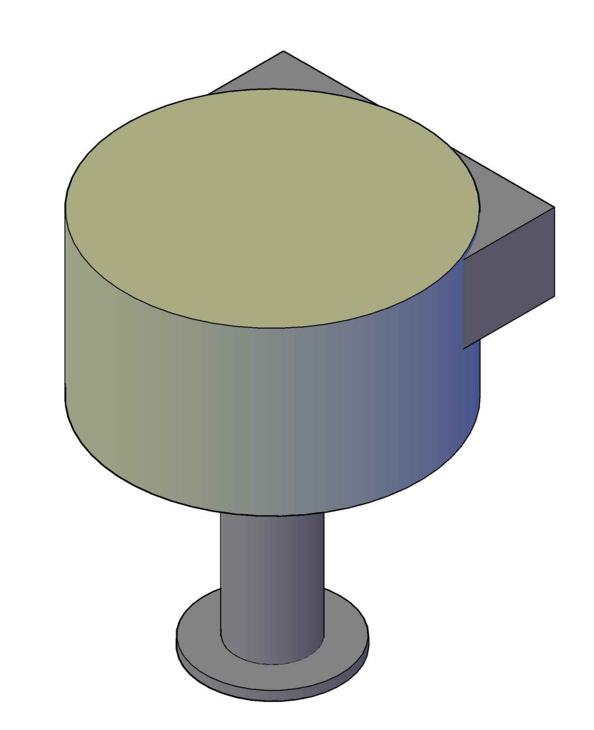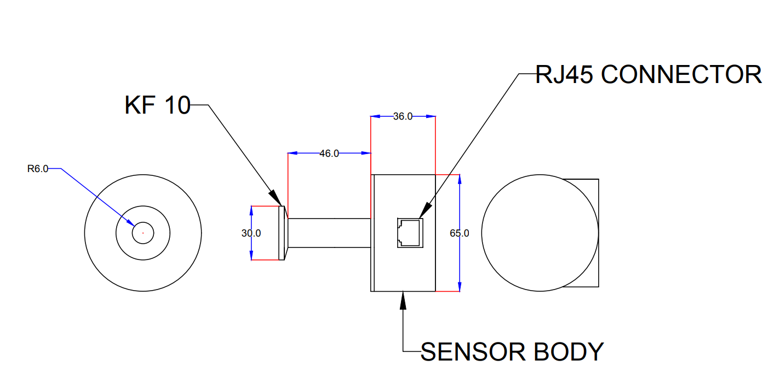

TECHNICAL SPECIFICATIONS
Vacuum Gauge Head | FG-04 sensor tube
Measuring Range | 20 mBar to 0.001mBar.
Temp. Range | +2 to +50 deg. Celsius
VAC and ATM Adjust | adjusted by trim pot at the signal conditioner PCB of the sensor.
Operating Voltage | +15V, -15V DC
Mounting | Vertical
Environmental Considerations | not for use with explosive or corrosive gases
Sensor cable | Standard RJ45 male plugs both ends- 2 mtrs long. Optional additional lengths available on request.
Applications: ■ Controlling high vacuum systems ■ Fore vacuum pressure monitoring ■ Safety circuits in vacuum systems ■ General vacuum measurement & control in the fine and rough vacuum range.
Calibration:
Unique Vacuum Solutions offers a convenient recalibration service to help users of vacuum measurement pirani/ thermocouple/ full range gauges to maintain all of their vacuum gauges in Certified and peak condition, regardless of the original manufacturer. All makes of vacuum gauges can also be calibrated / repaired if required.
The calibration certificates are available only on request at additional cost. Pl contact before ordering.

UNIQUE VACUUM SOLUTIONS
#57, 8th cross, 1st B cross, Doddanna industrial area main road, vishwaneedam post, Near Peenya 2nd stage, Bangalore -560091
Ph: 080-28367059, 9886726920. +91-support@uniquevacuum.co.in, www.uniquevacuum.co.in

